|  |  |
| --- | --- |
| Lab | Friday 9AM |
| Student No | - |
| Registered Programme | DN201 – Data Science |
| Date | 19th October 2018 |

# Step 1: Getting Started

Paste a picture of your planar graph here:

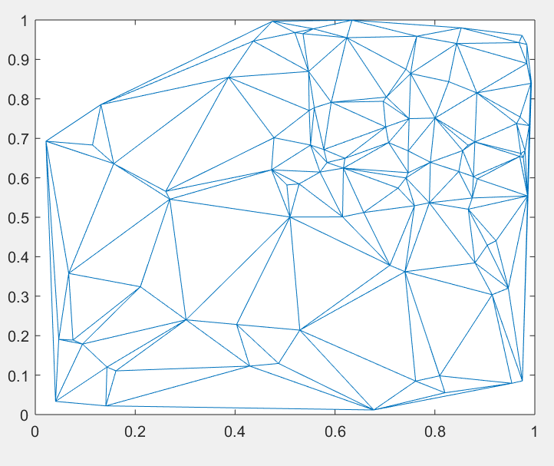

Paste a picture of the adjacency matrix here:

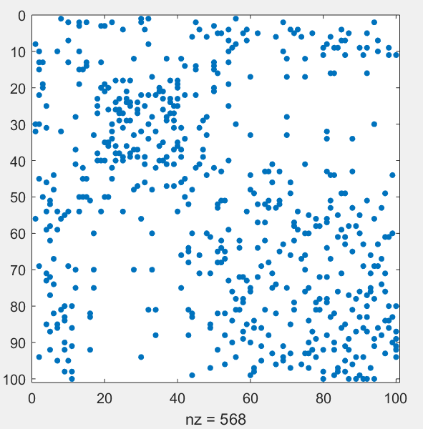

# Step 2: Running Simulated Annealing

Paste a picture of the reorganised adjacency matrix here:

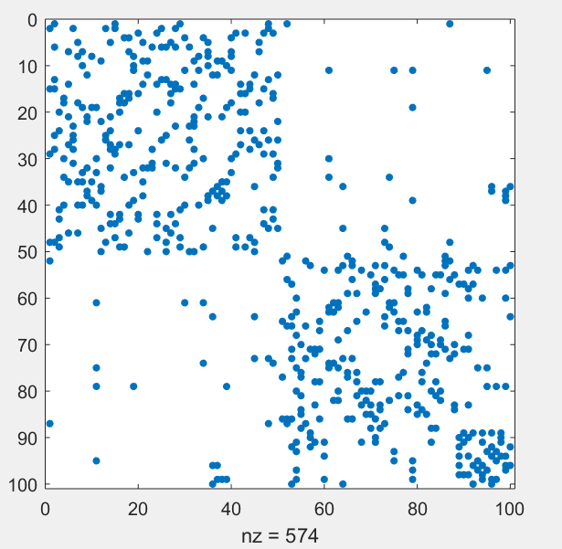

Paste a plot of *average* time vs *average* quality obtained for the Simulated Annealing algorithm run with the default set of parameters. State how many trials you averaged over?:

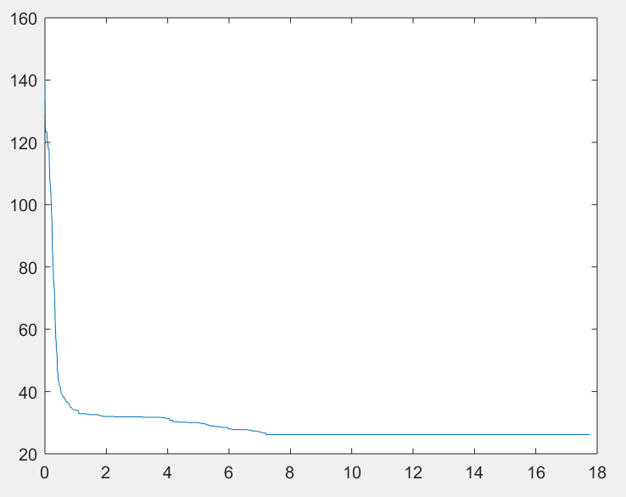

This was run over 7 trials

# Step 3: Effect of alpha:

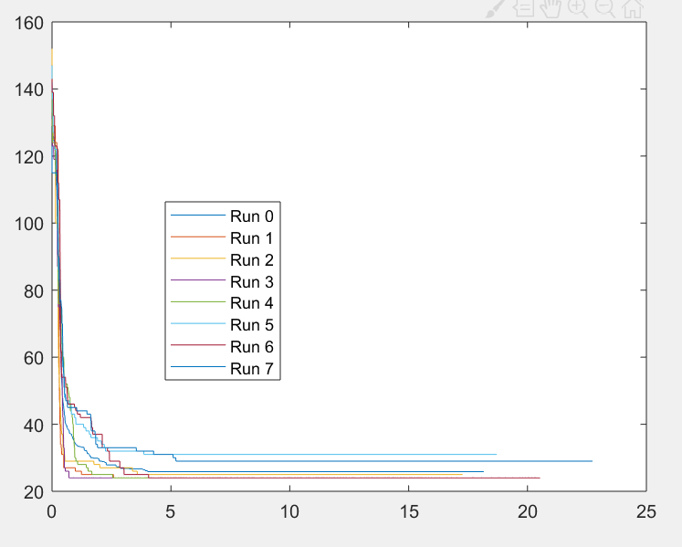

|  |  |  |  |  |
| --- | --- | --- | --- | --- |
| **alpha** | **maxGenerations** | **Best Edge Cut** | **Average Edge Cut** | **Average Time** |
| **0.8** | **100,000** | **26** | **40** | **17.79 sec** |
| **0.1** | **100,000** | **25** | **56** | **18.70 sec** |
| **0.3** | **100,000** | **25** | **47** | **15.94 sec** |
| **0.5** | **100,000** | **26** | **36** | **16.18 sec** |
| **0.9** | **100,000** | **25** | **33** | **16.37 sec** |
| **0.9999** | **100,000** | **107** | **113** | **16.90 sec** |

Paste a plot of the average time vs average quality for the best value of **alpha** found

Alpha = 0.9

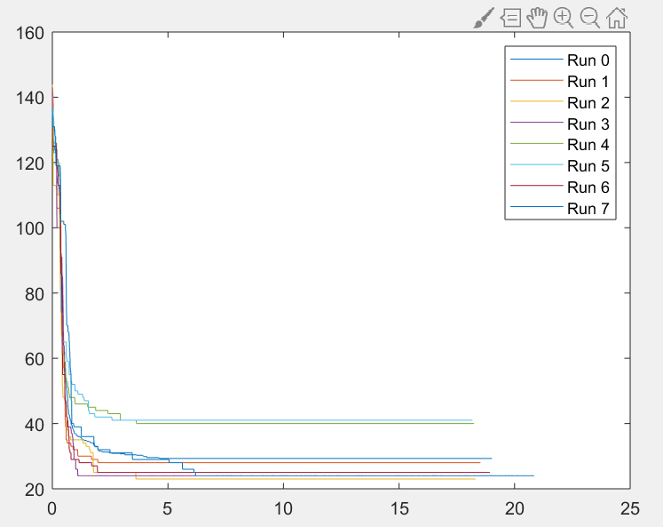

Is there an **alpha** value that you would recommend as clearly the best for this problem?

Alpha 0.8 <= 0.9

Is the convergence profile different for different values of **alpha** i.e. for some values of **alpha** does the quality reduce more rapidly over the first few iterations or settle down to a fixed value earlier/later than other values of **alpha**?

yes

What happens when **alpha** is small e.g. **alpha<0.5**?

When alpha is smaller that 0.5 the average time is higher, and the average cut edge is higher.

What happens when **alpha** is large e.g. **alpha>0.99**?

**The average cut edge and time is larger when alpha is higher than 0.9**

# Step 4: Effect of Markov Chain Length:

**alpha = 0.9**

|  |  |  |  |
| --- | --- | --- | --- |
| **proportion** | **Best Edge Cut** | **Average Edge Cut** | **Average Time** |
| **0.1** | **26** | **38** | **29.71** |
| **0.5** | **25** | **40** | **26.29** |
| **0.9** | **24** | **30** | **27** |

What is the best proportion for the Markov Chain length, taking into account that we are interested in the time as well as the quality of the solution?

**From my testing it appears that the closer to 1 the proportion is, the better the Results.**

# Step : 5 Effect of N:

|  |  |  |  |  |  |  |  |
| --- | --- | --- | --- | --- | --- | --- | --- |
| **N** | **alpha** | **maxGenerations** | **Chain prop** | **Best Edge Cut (SA)** | **Average Edge Cut (SA)** | **Best Edge Cut (spectral)** | **Average Time** |
| 100 | **0.9** | **100,000** | **0.9** | **24** | **36** | **27** | **27** |
| **1,000** | **0.9** | **100,000** | **0.9** | **24** | **35** | **27** | **25.14** |
| **10,000** | **0.9** | **100,000** | **0.9** | **23** | **36** | **27** | **23.18** |

Does best **alpha** depend on N?

**Apparently not.**

# Step : 6 Genetic Algorithms : Crossover and Mutation

**P = 10**

**N = 100**

|  |  |  |  |  |
| --- | --- | --- | --- | --- |
| **crossover Rate** | **mutation Rate** | **Best Edge Cut** | **Average Edge Cut** | **Average Time** |
| 0.5 | **0.1** | **24** | **24** | **43.21** |
| **0.1** | **0.1** | **26** | **24** | **29.93** |
| 0.1 | **0.9** | **24** | **31** | **71.93** |
| **0.5** | **0.9** | **24** | **32.14** | **111.13** |
| 0.5 | **0.1** | **24** | **35** | **54** |
| **0.9** | **0.1** | **24** | **41** | **67.87** |
| 0.9 | **0.9** | **23** | **44** | **112.2** |
|  |  |  |  |  |
|  |  |  |  |  |
|  |  |  |  |  |

What is the best combination of crossover and mutation rate?

It appears that the lower they are the better the time. The best edge doesn’t appear to change much but the average edge cut is best when mutation is high, and crossover is in the middle.

Which is more effective on this problem – crossover or mutation?

A lower mutation will provide a better time, while a higher mutation provides a higher average edge cut.

How do the results compare with simulated annealing? (Remember to take into account not just the final quality obtained but also the time it took to get it)

**These results appear to show that they give a better understanding that the Simulated Annealing.**

# Step : 7 Genetic Algorithms : Population Size

Based on 7 runs for the average

|  |  |  |  |  |
| --- | --- | --- | --- | --- |
| **N** | **P** | **Best Edge Cut** | **Average Edge Cut** | **Average Time** |
| **100** | **10** | **24** | **37** | **147.9** |
| **100** | **2** | **24** | **39** | **29.31** |
| **100** | **50** | **Too Slow Run** | **Too Slow Run** | **Too Slow Run** |
| **1,000** | **10** | **23** | **35** | **117.9** |
| **1,000** | **2** | **24** | **33** | **29.72** |
| **1,000** | **50** | **23** | **33** | **579.1** |
| **10,000** | **10** | **25** | **34** | **140.4** |
| **10,000** | **2** | **28** | **38.33** | **24.37** |
| **10,000** | **50** | **Too Slow Run** | **Too Slow Run** | **Too Slow Run** |

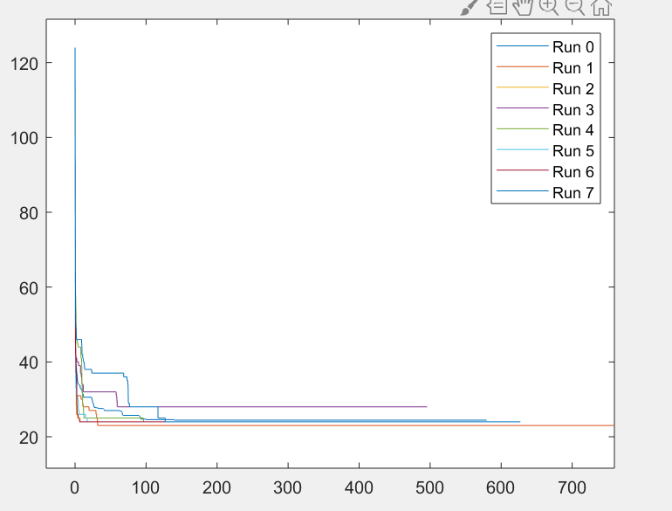**Example of a run**

Does the best population size depend on the size of the graph?

Yes, the population size increases then the size of graph should be smaller

Which is better, Simulated Annealing or Genetic Algorithms for the graph partitioning problem ? Why?

**Genetic Algorithms, as these algorithms will be able to produce better quality results quicker**